Group 3:

Tejesh Rathi

Palak Agrawal

Sonali Chaudhari

Abstract

All the views with its resultset

IMDB

Internet Movie Database

-----------------------------------------------------------------------------------------

/*Databases : SQL Server

Author : Group 3

Creation Date : 12-06-2016

Query Number : 1

Query : View for Award Details*/

-----------------------------------------------------------------------------------------

SELECT * FROM AWARD.v_AWARD_DETAILS;

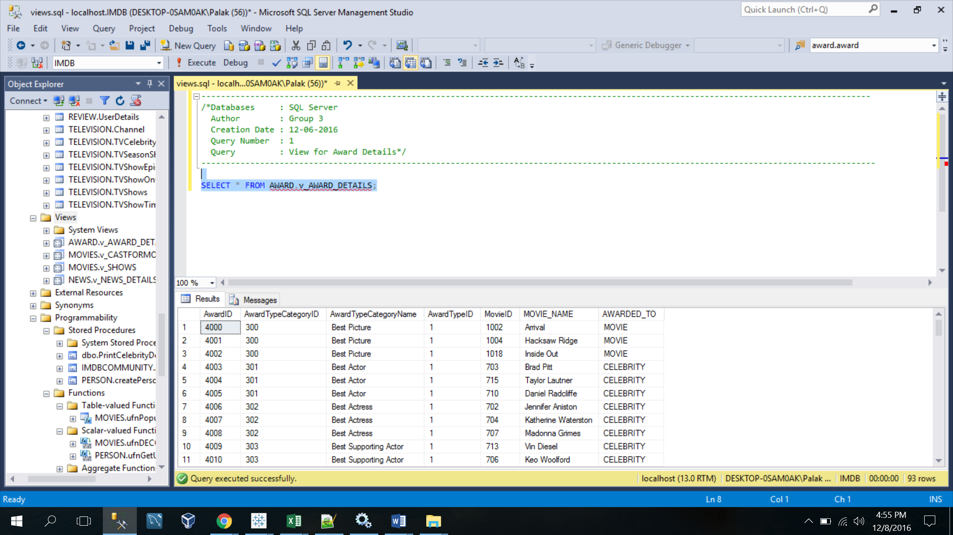

-----------------------------------------------------------------------------------------

/*Databases : SQL Server

Author : Group 3

Creation Date : 12-06-2016

View Definition : To retrieve each category of award awarded and its details*/

------------------------------------------------------------------------------------------

CREATE VIEW AWARD.v_AWARD_DETAILS AS

SELECT

A.AwardID,

A.AwardTypeCategoryID,

ATC.AwardTypeCategoryName,

A.AwardTypeID,

A.MovieID,

M.Name AS MOVIE_NAME,

"AWARDED_TO" = 'MOVIE'

FROM AWARD.Award A

INNER JOIN AWARD.AwardTypeCategory ATC

ON ATC.AwardTypeCategoryID = A.AwardTypeCategoryID

INNER JOIN AWARD.AwardType AT

ON AT.AwardTypeID = ATC.AwardTypeID

INNER JOIN MOVIES.Movie M

ON A.MovieID = M.MovieID

UNION

SELECT

A.AwardID,

A.AwardTypeCategoryID,

ATC.AwardTypeCategoryName,

A.AwardTypeID,

A.CelebrityID,

C.Name AS CELEBRITY_NAME,

"AWARDED_TO" = 'CELEBRITY'

FROM AWARD.Award A

INNER JOIN AWARD.AwardTypeCategory ATC

ON ATC.AwardTypeCategoryID = A.AwardTypeCategoryID

INNER JOIN AWARD.AwardType AT

ON AT.AwardTypeID = ATC.AwardTypeID

INNER JOIN PERSON.Celebrity C

ON C.CelebrityID = A.CelebrityID;

--------------------------------------------------------------------------------

/*Databases : SQL Server

Author : Group 3

Creation Date : 12-06-2016

Query Number : 2

Query : View for News Details*/

---------------------------------------------------------------------------------

SELECT * FROM NEWS.v_NEWS_DETAILS;

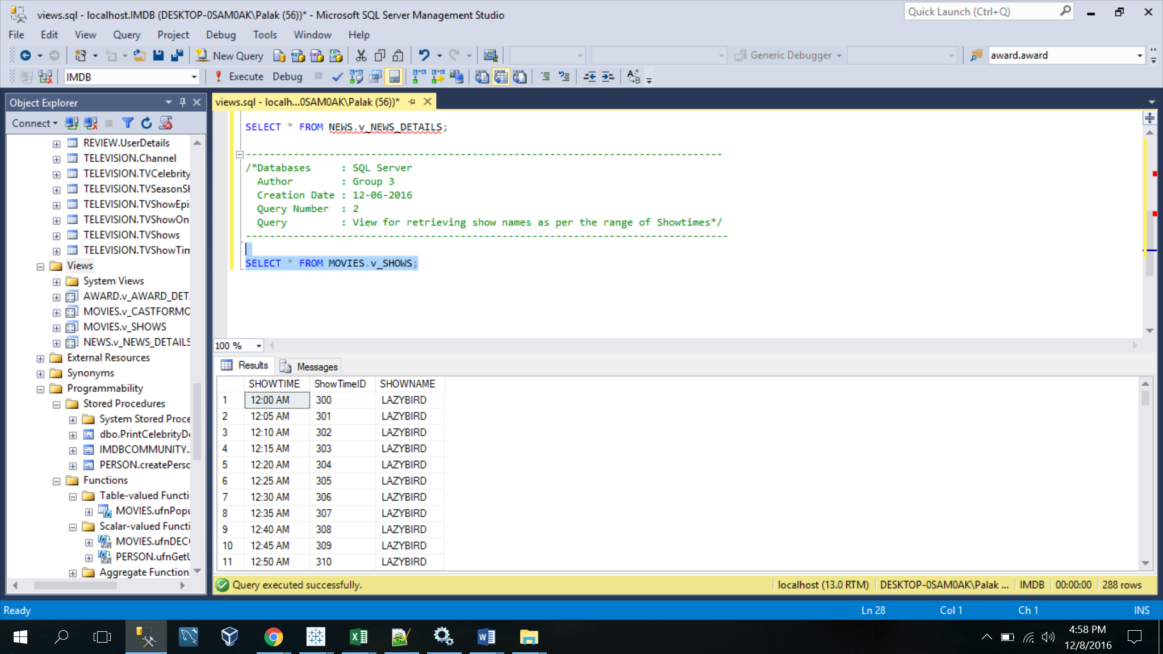

------------------------------------------------------------------

/*Databases : SQL Server

Author : Group 3

Creation Date : 12-06-2016

View Definition : To retrieve each type of news and its details*/

--------------------------------------------------------------------

CREATE VIEW NEWS.v_NEWS_DETAILS AS

SELECT

NOC.NewsChannelID,

NC.NewsChannelName,

MN.MovieNewsID AS NewsID,

MN.News,

M.MovieID AS ID,

M.Name AS NEWSTYPENAME,

"NEWSTYPE" = 'MOVIENEWS'

FROM NEWS.NewsOnChannel NOC

INNER JOIN NEWS.NewsChannel NC

ON NOC.NewsChannelID = NC.NewsChannelID

INNER JOIN NEWS.MovieNews MN

ON NOC.MovieNewsID = MN.MovieNewsID

INNER JOIN MOVIES.Movie M

ON MN.MovieID = M.MovieID

UNION

SELECT

NOC.NewsChannelID,

NC.NewsChannelName,

TN.TVShowNewsID AS NewsID,

TN.News,

T.TVShowID AS ID,

T.Name,

"NEWSTYPE" = 'TVNEWS'

FROM NEWS.NewsOnChannel NOC

INNER JOIN NEWS.NewsChannel NC

ON NOC.NewsChannelID = NC.NewsChannelID

INNER JOIN NEWS.TVNews TN

ON NOC.TVShowNewsID = TN.TVShowNewsID

INNER JOIN TELEVISION.TVShows T

ON TN.TVShowID = T.TVShowID

UNION

SELECT

NOC.NewsChannelID,

NC.NewsChannelName,

CN.CelebrityNewsID,

CN.News,

C.CelebrityID AS ID,

C.Name,

"NEWSTYPE" = 'CELEBRITYNEWS'

FROM NEWS.NewsOnChannel NOC

INNER JOIN NEWS.NewsChannel NC

ON NOC.NewsChannelID = NC.NewsChannelID

INNER JOIN NEWS.CelebrityNews CN

ON CN.CelebrityNewsID = NOC.CelebrityNewsID

INNER JOIN PERSON.Celebrity C

ON C.CelebrityID = CN.CelebrityID;

--------------------------------------------------------------------------------

/*Databases : SQL Server

Author : Group 3

Creation Date : 12-06-2016

Query Number : 3

Query : View for retrieving show names as per the range of Showtimes*/

---------------------------------------------------------------------------------

SELECT * FROM MOVIES.v_SHOWS;

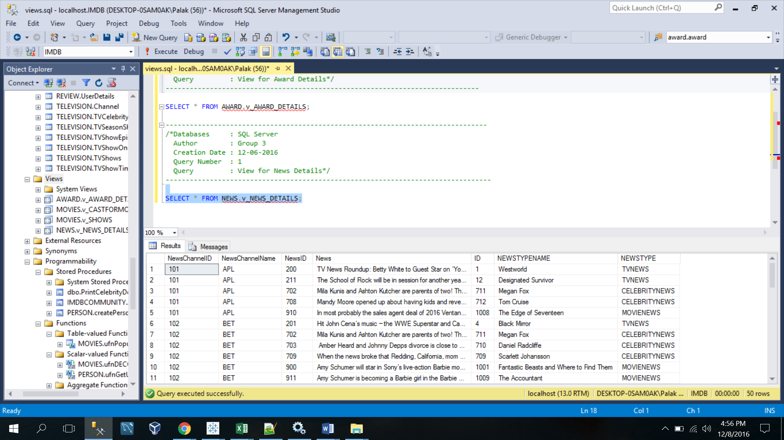

-----------------------------------------------------------------------------

/*Databases : SQL Server

Author : Group 3

Creation Date : 12-06-2016

View Definition : To retrieve each type movie show according to the show times*/

----------------------------------------------------------------------------------

CREATE VIEW MOVIES.v_SHOWS AS

SELECT FORMAT(CAST(ShowTime AS DATETIME),'hh:mm tt') AS SHOWTIME,ShowTimeID, "SHOWNAME" =

CASE

WHEN ShowTimeID BETWEEN 400 AND 432 THEN 'EARLYBIRDS'

WHEN ShowTimeID BETWEEN 433 AND 505 THEN 'BIRDSOFDAY'

WHEN ShowTimeID BETWEEN 506 AND 552 THEN 'BIRDSOFEVE'

WHEN ShowTimeID BETWEEN 553 AND 587 THEN 'BIRDSOFNIGHT'

ELSE 'LAZYBIRD'

END

FROM MOVIES.ShowTime;

--------------------------------------------------------------------------------

/*Databases : SQL Server

Author : Group 3

Creation Date : 12-06-2016

Query Number : 4

Query : View for retrieving celebrity name and their type for each movie*/

---------------------------------------------------------------------------------

SELECT * FROM MOVIES.v_CASTFORMOVIE;

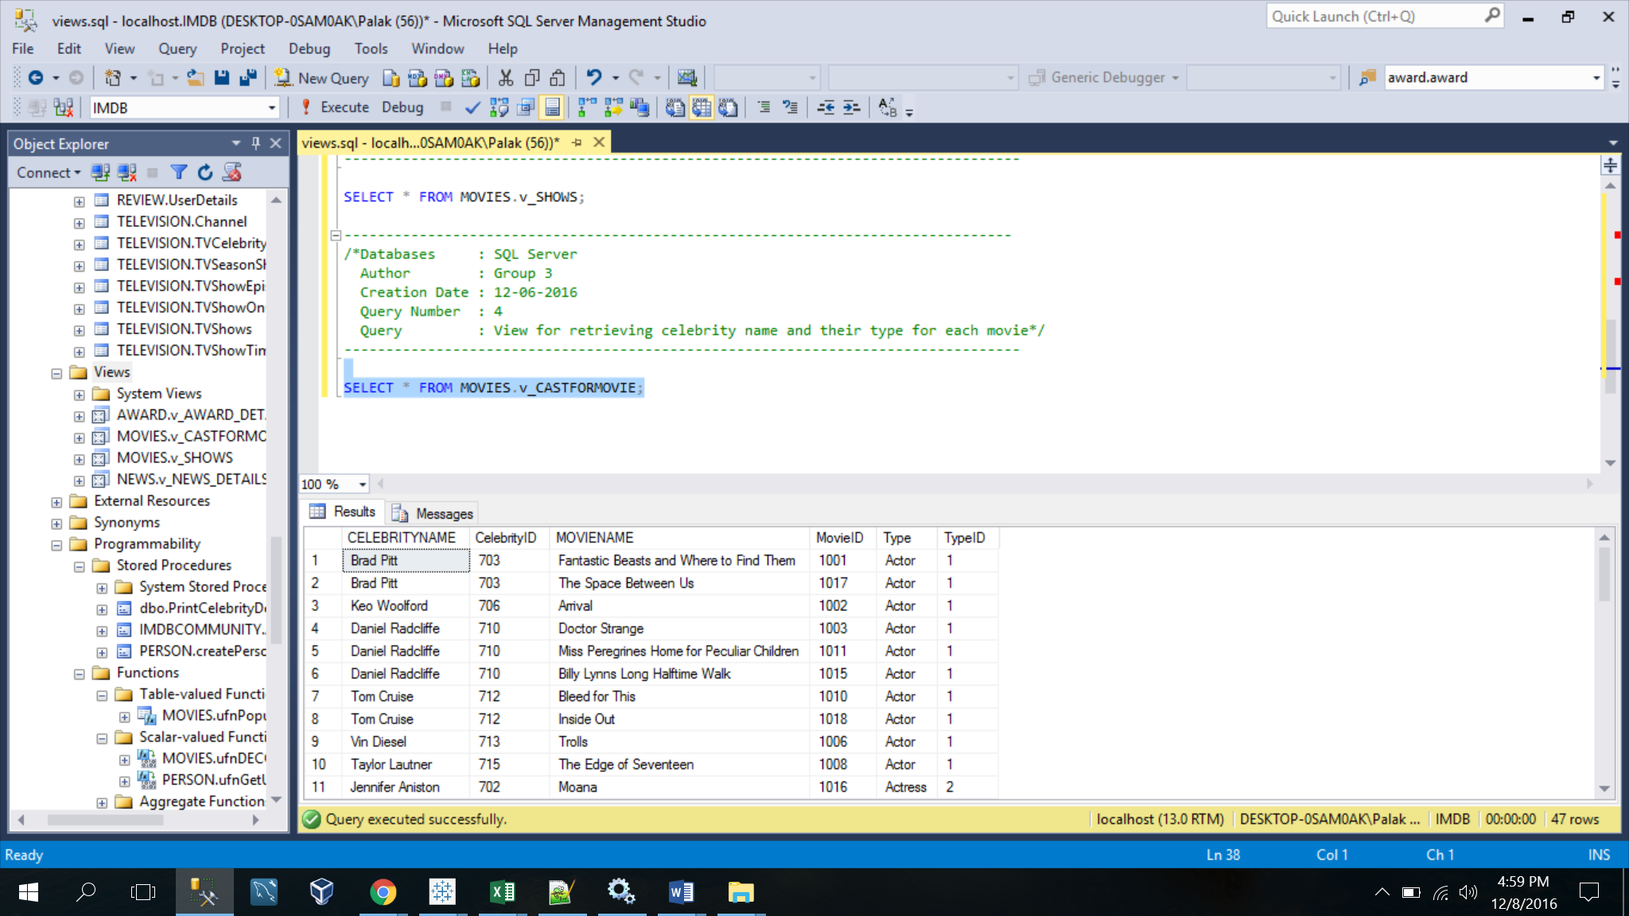

---------------------------------------------------------------------------------

/*Databases : SQL Server

Author : Group 3

Creation Date : 12-06-2016

View Definition : To retrieve the each type of celebrity casted in each movie*/

----------------------------------------------------------------------------------a

CREATE VIEW MOVIES.v_CASTFORMOVIE AS

SELECT DISTINCT cel.Name AS CELEBRITYNAME,

CEL.CelebrityID,

m.Name AS MOVIENAME,

M.MovieID,

TC.Type,

TC.TypeID

FROM PERSON.TypeOfCelebrity tc

LEFT JOIN PERSON.CelebrityType ct

ON ct.TypeID = tc.TypeID

left join PERSON.Celebrity cel

ON cel.CelebrityID = ct.CelebrityID

LEFT JOIN MOVIES.MovieCelebrity mcel

ON mcel.CelebrityID = cel.CelebrityID AND CT.TypeID = MCEL.TypeID

LEFT JOIN MOVIES.Movie m

ON m.MovieID = mcel.MovieID

WHERE M.MovieID IS NOT NULL;